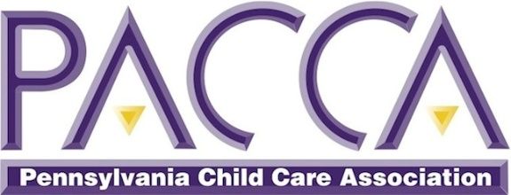
Application: Anti-Racist Work Group for Early Childhood Educators
(Evening Sessions – April 2021)

Your Name:
Early Childhood Education Program Name:
Your Address:
Cell:
Email:

Please briefly answer each of the following questions
1. What comes to your mind when you hear, “White ANTI-Racist Educator”?
2. Have you taken any training around being an anti-racist
3. How have you evolved around the topic of racism over the last 6 months? If you participated in the Nov/Dec PACCA Anti-Racist workgroup, what changes did that participation spark in you?
4. Summarize any previous anti-racist activism or work you have done
5. Do you commit to actively participating in all four sessions and completing all assignments as part of this work group (assignments will take an hour -90 minutes per week to complete)?

If accepted, would you like to receive PD Registry (PQAS) and/or Act 48 credits upon completion of all four sessions? If yes, please provide the applicable ID #. There is no additional charge for either type of credits.
____ PA PD Registry ID #:
____ PPID # (For Act 48):
____ N/A

Return completed application to maureen.murphy@pacca.org by 11:59 pm on Friday, March 19. Subject line: PACCA Anti-Racist Work Group

